|  |  |
| --- | --- |
| **Project ICAROS**  **Report Code** | DE-PJVRS-2017-04-30 |
| **Title** | **ICAROS LEAFLET** |
| **Start/End Date** | 2017/02/15 - 2017/03/27 |
| **Coordinator name and email** |  |
| **Name of teachers** | Jörn Trautmann |
| **Number and age of students** | 18 students with the subject “Computer science and economics”  17-21 years old. |
| **Description of activities** | Constructing a database by setting up an Entity-Relationship-Model for further programming an SQL-Script for it which helps the logistical process for the supply chain of ICAROS II. |
| **Learning outcomes** | The aim of the project is to implement the curricular topics of the students in the logistical process of the possibilities to find a supplier for the drone parts.  The project showed the possibilities to implement regular topics of the curriculum in the topic of the project. The students were high motivated because the project gave them the sense for how a database is constructed in order to aid the supply chain.  They enhanced even their language skills, because they had to present their results in English language.  The results can be used to help further projects i.e. for the construction process of ICAROS II. |

|  |  |
| --- | --- |
| **Photos or other relevant material** | Tasks:      Results see next page: |

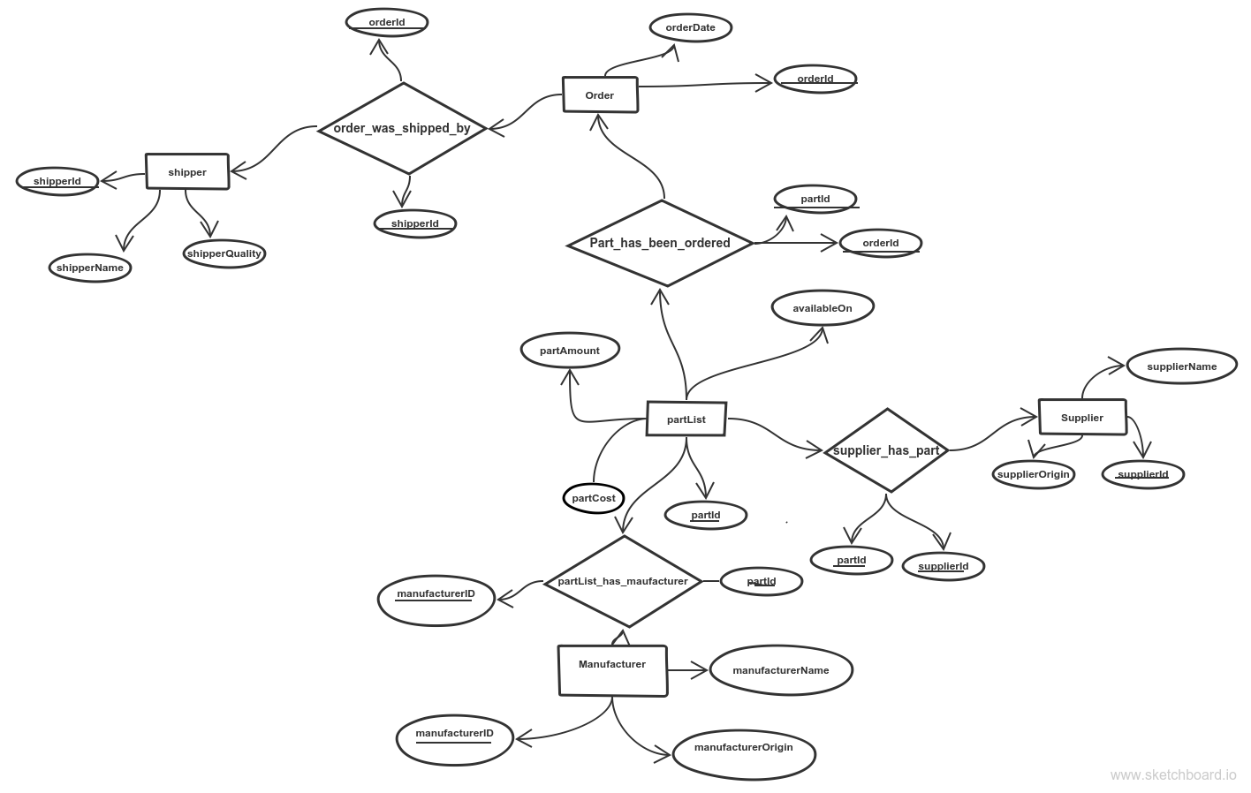

**ER-diagram**

drop database if exists drohne;

create database if not exists drohne;

use drohne;

create table if not exists partlist(partid integer not null auto_increment, partcost float, availableon date, partamount integer, primary key(partid));

create table if not exists supplier(supplierid integer not null auto_increment, supplierorigin varchar(50), suppliername varchar(20), primary key(supplierid));

create table if not exists manufacturer(manufacturerid integer not null auto_increment, manufacturername varchar(50), manufacturerorigin varchar(50), primary key(manufacturerid));

create table if not exists supplier_has_part(supplierid integer not null, partid integer not null);

create table if not exists patlist_has_manufacturer(partid integer not null, manufacturerid integer not null);

**SQL-Script**